Day 9 – Attend Industry Workshops and Events

Welcome to Day #9. We are 75% through the course. How are you feeling so far?

Information overload?

Well no one ever said it would be easy. But then again things that are valuable come at a steep price.

What is a Lamborghini cost $20,000? Would it be considered valuable? What if a Rolex was only $199 and you could buy it at Wal-Mart, would it still be considered luxury?

Today we are discussing the value of attending industry workshops and events. I can not overstate the importance of this single activity and the potential rewards that it can deliver.

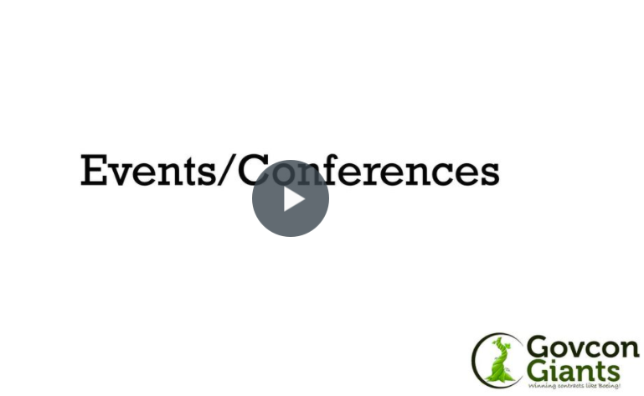

Teach me everything about events

P.S. Mostly everything that I learned about federal contracting came from workshops, events and conferences or people that I met at workshops, events and conferences. Remember most resources in the federal arena costs thousands of dollars. When I started I didn’t have any money. So I relied on inexpensive techniques to expand my ideas and grow my business.

Eric Coffie

